The Impact of the “Lazy S” Feature on the Mechanical Properties of a Self-Reacting Friction Stir Weld Made on 2024-T4 Aluminum

Prepared By:
Joshua Walters
Faculty Advisors:
Dr. Michael West
SDSMT Advanced Material Processing Center
Dr. Alfred Boysen
Professor, Department of Humanities
Program Information:
National Science Foundation
Grant # 0852057
Research Experience for Undergraduates
Summer 2011
South Dakota School of Mines and Technology
501 East Saint Joseph Street
Rapid City, SD 57701
Table of Contents
Abstract……………………………………………………………………………3
Objectives
Findings
Introduction………………………………………………………………………..3
Background
Objectives
Broader Impact………………………………………………………………….…4
Procedure………………………………………………………………………….5
Materials
Equipment
Procedures
Results……………………………………………………………………………..7
Metallographic Analysis
Micro-Hardness Testing
Tensile Testing
Discussion…………………………………………………………………………12
Conclusion………………………………………………………………………..14
Future Work……………………………………………………………….……..14
Acknowledgements……………………………………………………………….14
References………………………………………………………………………...15
Abstract
This investigation focuses on the “Lazy S” defect that occurs in Friction Stir Welding (FSW), and its impact on the mechanical properties of a 2024 T-4 Aluminum weld made with a self-reacting tool. Welding parameters that promoted the “Lazy S” defect were experimentally determined, and then a series of welds were made using those welding parameters. The welds were subjected to tensile, fatigue, and hardness testing, as well as metallographic examination. After testing, results indicated that the presence of the “Lazy S” defect had seriously compromised the mechanical properties of the weld, specifically the tensile properties.
Key Words: Friction Stir Welding; Self-Reacting Tool (SRT); Lazy S

Introduction
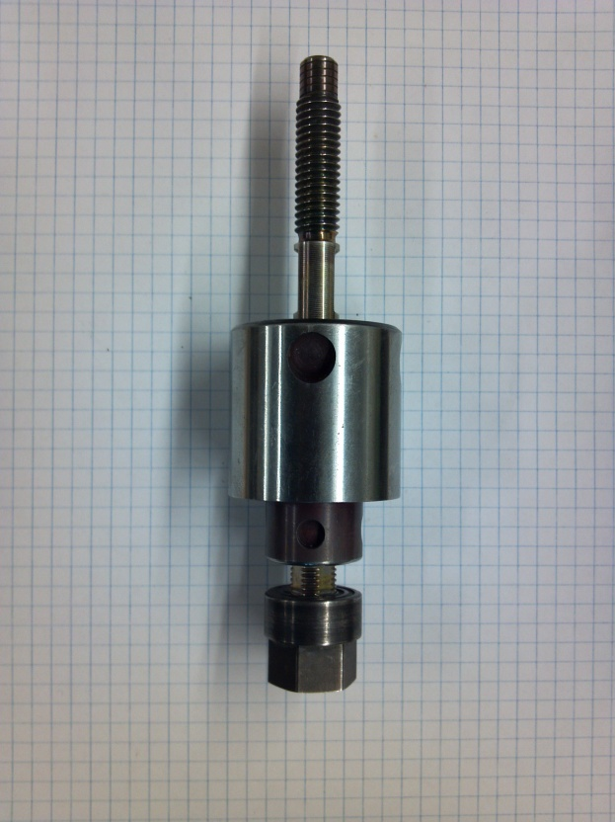
Friction Stir Welding and Processing is still developing technologically. An integral part of any friction stir process is the large amount of force necessary to forge materials into one solid piece. This introduces limitations, since an opposing surface is necessary to maintain such large forces. An interesting development that overcomes this problem is the Self-Reacting Tool (See Figure 1). Instead of having an anvil under the weld material to provide the opposing force required for friction stir welding, the SRT uses a lower shoulder that employs a pinching action to the joint to apply the required force. This gives the weld profile of a self-reacting friction stir weld unique characteristics compared to conventional friction stir processes, but they share many of the same weld defects. The “Lazy S” defect is the primary focus of this investigation. The “Lazy S” defect is formed due to the oxide layer built up on the faying surfaces of two pieces of metal. As the pin passes through the material, the oxide layer is stirred in to the weld, and then deposited in the zigzag d pattern referred to as the “Lazy S”. [1] This study focuses on the “Lazy S” defect, and its impact on the mechanical properties of a weld made using 2024-T4 Aluminum.
Figure 1: A self-reacting friction stir welding tool

Broader Impact
One of the main constraints with any friction stir process is the large amount of force that is needed to forge materials into a solid member. As mentioned in the introduction, some type of opposing surface is needed in order to impart the force on the weld joint without distorting the work piece. This limitation seriously restricts the applications of FSW in two ways: it sabotages many of the potential applications, and it severely limits the fabrication versatility.
Many potential applications of friction stir processing are hampered by the fact that the process needs some way to impart a substantial force on the weld joint. The necessity of an anvil makes the process virtually immobile; therefore, the only feasible applications for friction stir processes must be in an industrial setting where bulky machinery is acceptable. Applications that involve “in the field” repairs are out of the question, as wells as most post-production renovations. Such applications could include infrastructure repair, airplane repair, ship repair, and construction renovations.
Regarding fabrication, many welding configurations cannot be used with FSW because the configurations make it impractical or impossible for a supportive anvil to be used. Many industrial fields could benefit greatly from friction stir processes if there was just a way to realistically apply the technology. For instance, the pressure vessel and pipe welding fields could benefit greatly from FSW because of the lack of weld defects and high quality of the welds, but it is virtually impossible to weld any type of enclosed shape with FSW because there is no practical way to support the back of the weld joint throughout the entire fabrication process.
The use of a SRT could help to resolve both of these issues. Since the SRT uses an opposing shoulder to pinch the material into a forged joint, there is no need for an opposing surface to provide a reactionary force. The possibility of a mobile FSW machine that could perform welds in the field could be realized, and more complicated welding configurations could be used. The only obstacle to overcome is the acceptability of the SRT as a means of producing quality friction stir welds. My investigation into the impact of the “Lazy S” defect on the mechanical properties of a 2024-T4 Aluminum weld made with a self-reacting tool is a step toward gaining that acceptability.
Procedure
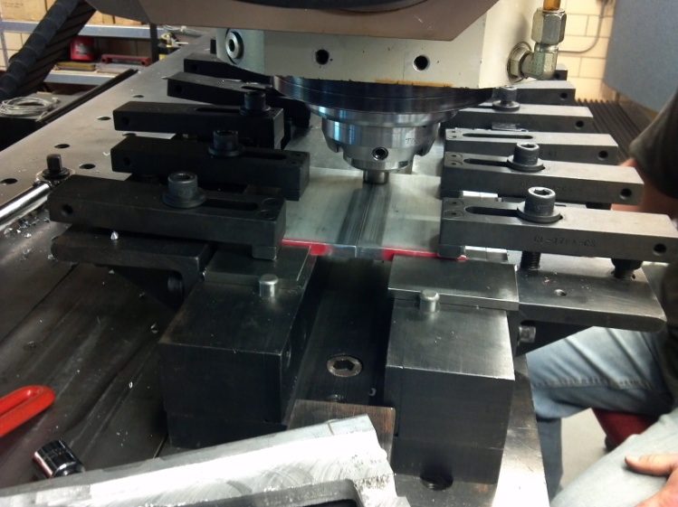
The material used throughout the project was 2024-T4 Aluminum. The aluminum was received in a .375” x 6” x 72” piece. The weld joint was made by cutting 6” lengths from the original piece, then cutting the 6” piece in half. The halves were then butted together to form the weld joint. (See Figure 2) A drilled-hole start was used for each weld, and each weld was given a 30 second pre-heat period before traversing the weld joint. Before any butt joints were made, a series of bead-on-plate welds were made to determine acceptable parameters for the experiment using a MTS ISTIR 10 Gantry Multi-axis FSW machine in force control. (See Table 1) The initial bead-on-plate welds were only subjected to metallographic analysis. After the welds were made, the macro-structure was evaluated for weld defects. Since it is believed that lower spindle speeds promote the formation of the “Lazy S” defect, it was decided that a spindle speed of 230 RPM and a travel speed of 5 IPM would be used throughout the experiment. [2] A steel SRT was used for each weld throughout the experiment. The pin had a quad-flat design and had a diameter of 1.1 cm. Both the upper and lower shoulders of the tool were 2.3 cm in diameter, and had a scrolled inward profile.
Figure 2: A butt weld made using a self-reacting tool.
Table 1
Weld # | Spindle Speed | Travel Speed | Upper Shoulder | Lower Shoulder | Defective
001 | 230 RPM | 8 IPM | 5 lb | -2500 lb | Yes
002 | 230 RPM | 5 IPM | 5 lb | -2500 lb | No
003 | 230 RPM | 11 IPM | 5 lb | -2500 lb | Yes
004 | 430 RPM | 8 IPM | 5 lb | -2500 lb | No
005 | 430 RPM | 5IPM | 5 lb | -2500 lb | No
006 | 430 RPM | 11 IPM | 5 lb | -2500 lb | No

After the weld parameters were established, six butt joint style welds were made. (See Table 2) Welds 007 and 008 were unusable due to a clamping issue during welding. A significant amount of spreading occurred during the welding process, which severely distorted the welds. Weld 009 was made using the previously mentioned parameters. The faying surfaces of the butt joint were both stock surface, meaning they still contained the surface oxide layer. Weld 010, on the other hand, had a milled surface on the advancing side, and a stock surface on the retreating side. Weld 011 was made with two stock surfaces making up the joint line, but the weld pin was offset by 1.5 mm toward the advancing side of the weld. Weld 012 was similar, but with a 3 mm offset toward the advancing side.
Table 2
Weld Sample | Advancing Side | Retreating Side | Offset Distance (mm)
009 | Stock | Stock | 0
010 | Milled | Stock | 0
011 | Stock | Stock | 1.5
012 | Stock | Stock | 3

Metallographic Analysis
After the welds were made, weld samples were cut to give a cross-sectional survey of the weld. The samples were mounted using a LECO PR-25 Bakelite mounting machine. After the welds samples were mounted, they were ground, polished, and etched. The grinding and polishing was done with a LECO Spectrum System 1000. The weld 001-006 were etched using Keller’s etchant, while welds 009-012 were first etched with a 10% NaOH solution, lightly re-polished, and then etched with Keller’s etchant. Grinding, Polishing, and Etching times can be found in Tables 3-5.

Table 3 Grinding Process Table 4 Polishing Process Table 5 Etching Times

Grit | Time |  | Suspension | Time |  | Etchant | Time
240 Grit | 120 s |  | 9 μm | 120 s |  | NaOH | 300 s
400 Grit | 120 s |  | 6 μm | 120 s |  | Keller’s | 180 s
600 Grit | 100 s |  | 3 μm | 100 s
800 Grit | 80 s |  | 1 μm | 80 s
1200 Grit | 80 s

Mechanical Testing
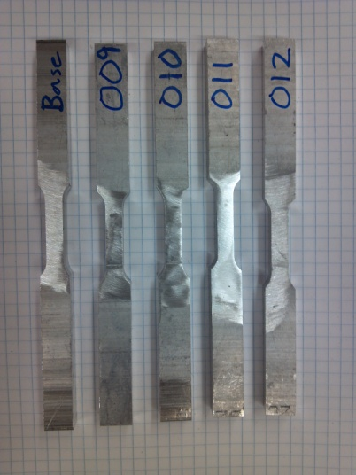
Micro-hardness testing was conducted using a Buehler LTD. Micromet 4 indenter. Indentations were made horizontally along the centerline of the weld’s cross-section at .025” intervals. Only one sample was surveyed for each weld. The base metal hardness was calculated by taking the average of five micro-hardness measurements on the base metal.
Tensile testing was performed using a MTS 810 Material Testing System. Tensile specimens were sub-sized based on the ASTM standard [3]. (See Figure 3) The tensile samples were 0.5” x 0.376” x 6”, and had a gauge length of 1”.
Figure 3: Tensile samples prior to testing

Results
Metallographic Analysis
Metallographic analysis revealed an observable “Lazy S” formation in welds 009-012. Welds 009 and 010 had smaller “Lazy S” formations along the root of the weld, while welds 011 and 012 had well defined “Lazy S” defects that completely traversed the depth of the weld.
Weld 009
Weld 009 had small signs of “Lazy S” formation near the lower root of the weld. The defect started at the root near the center of the weld, and extended upward until it terminated less than 1 mm away from the bottom of the weld. (See Figure 4-7)
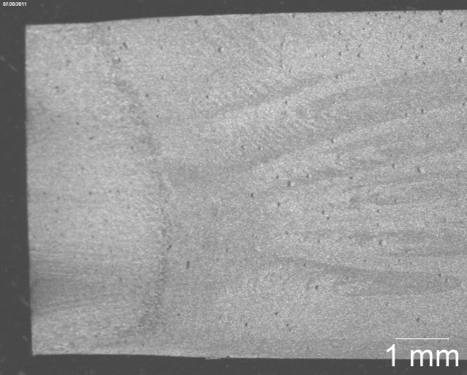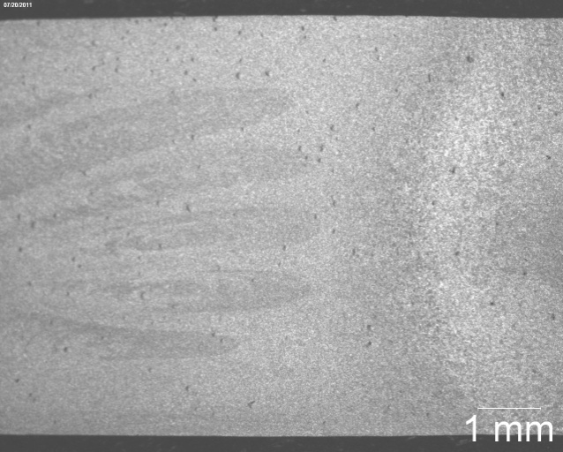
Figure 4: Advancing side of weld 009 Figure 5: Retreating side of weld 009
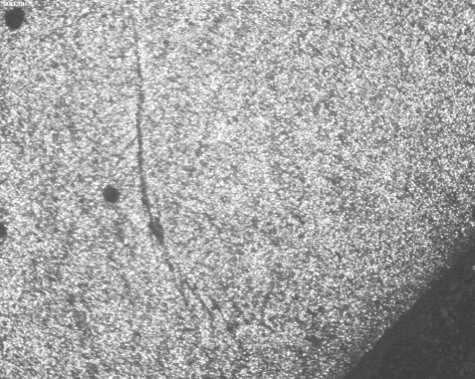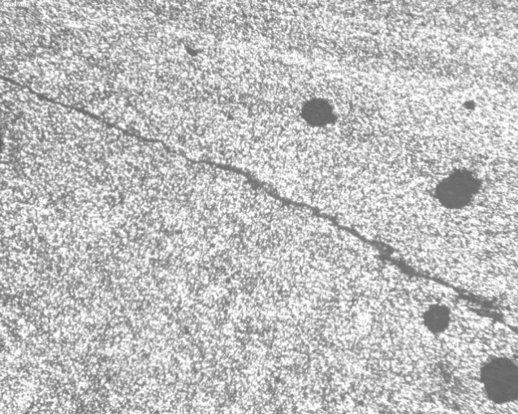
Figure 6: “Lazy S” near the root of weld 009 Figure 7: Magnified “Lazy S” in weld 009 (50x)
Weld 010
Weld 010 had the least amount of “Lazy S” formation out of all the welds. The only sign of the defect was a very small occurrence near the lower root of the weld. (See Figures 8-10)
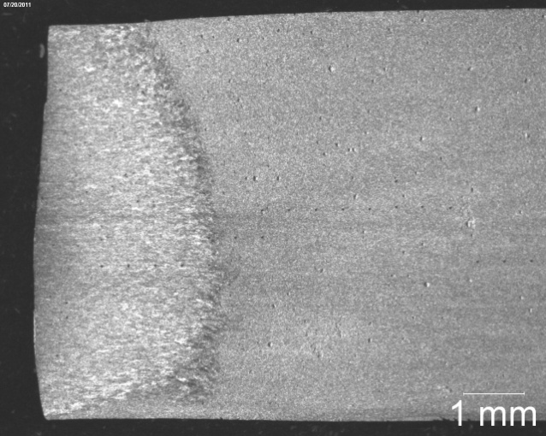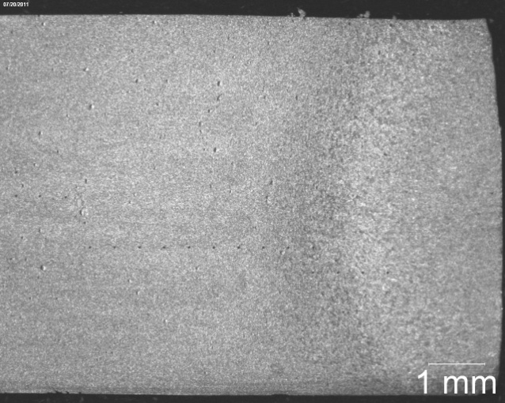
Figure 8: Advancing side of weld 010 Figure 9: Retreating side of weld 010
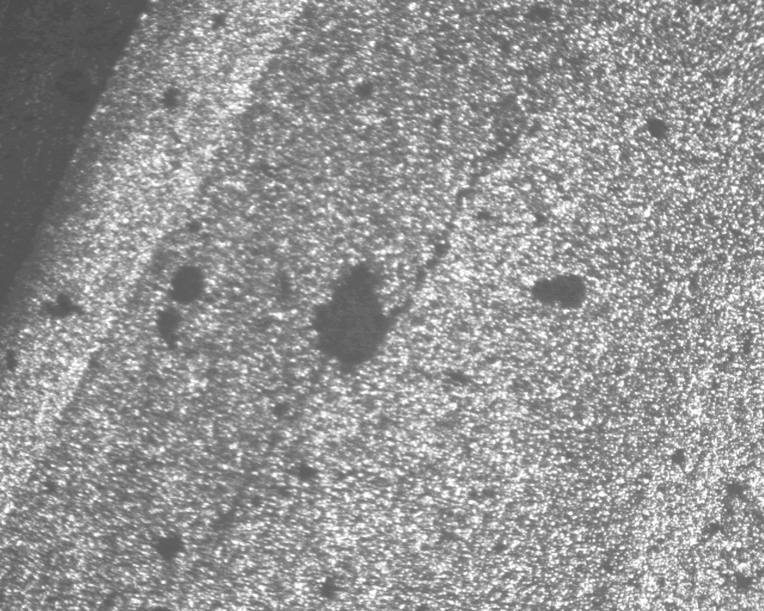
Figure 10: Magnified “Lazy S” defect in weld 010 (50x)
Weld 011
Weld 011 had a fully formed “Lazy S” that traversed the full thickness of the plate on the retreating side of the weld. Even though the defect is fully formed, it is very hard to see through on the photographs. This weld also had a consolidation defect on the advancing side. (See Figures 11-14)

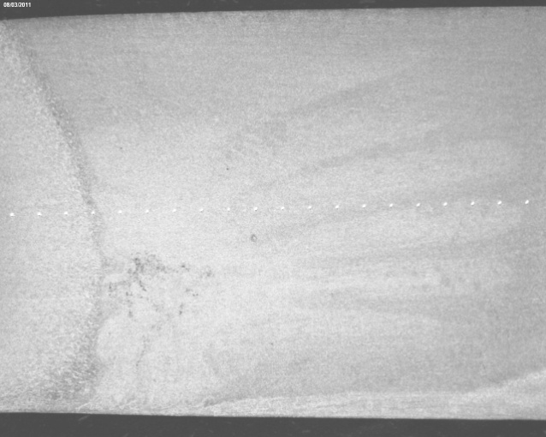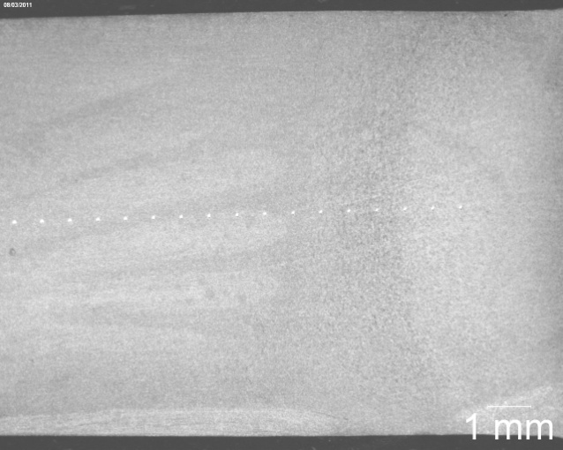
Figure 11: Advancing side of weld 011 Figure 12: Retreating side of weld 011

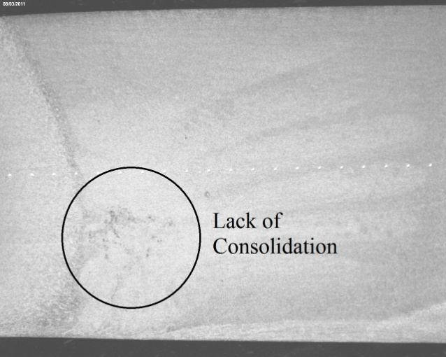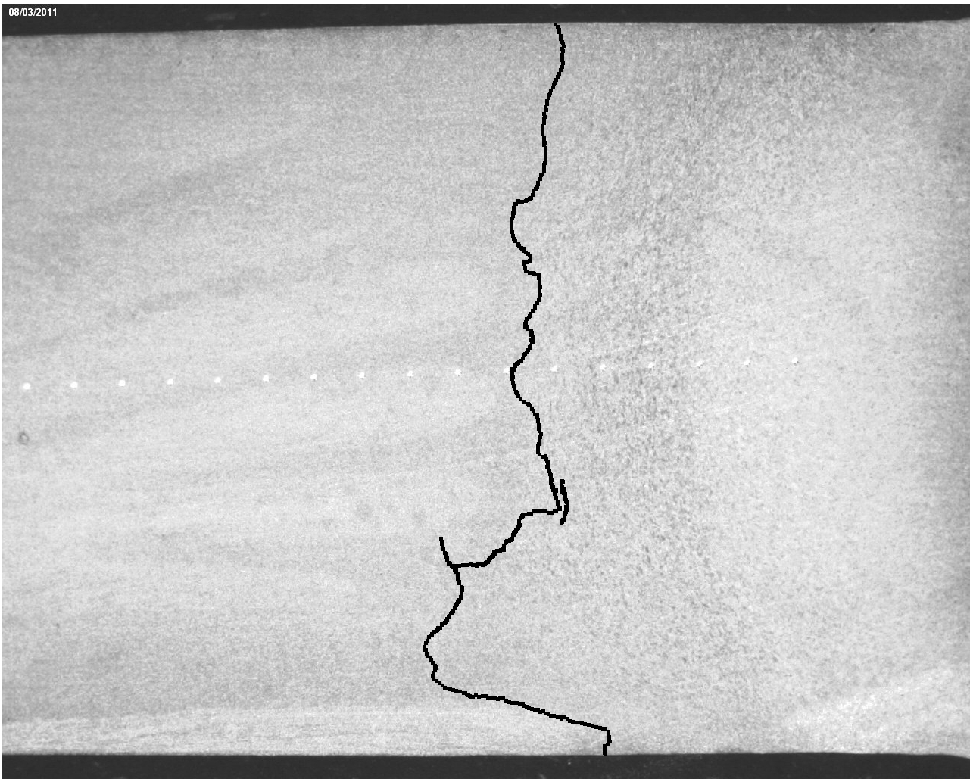
Figure 13: Consolidation defect in weld 011 Figure 14: Highlighted “Lazy S” formation in weld 011

Weld 012
Weld 012 also had a completely formed “Lazy S” that fully penetrated the thickness of the plate along the retreating side. As in weld 011, it was very difficult to identify it using only photographs. It lacked the consolidation defect that was seen in weld 011. (See Figures 15-17)
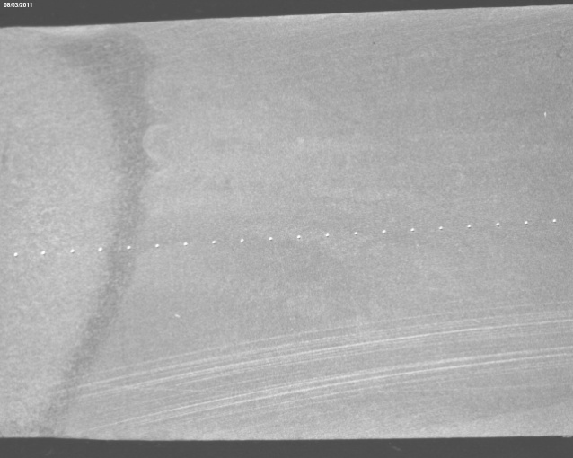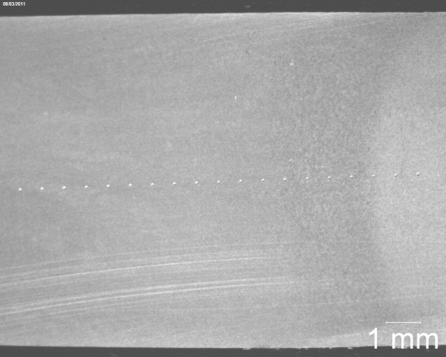
Figure 15: Advancing side of weld 012 Figure 16: Retreating side of weld 012
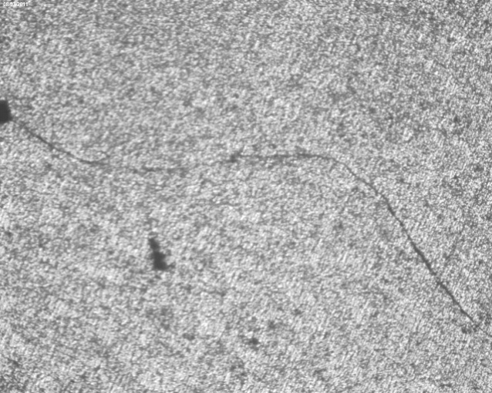
Figure 17: “Lazy S” formation in weld 012
Micro-Hardness Testing
Micro-hardness testing showed very little difference in the hardness of the material. The Vickers hardness ranged from approximately 110-150 along the welds. (Figure 18) The average hardness of the base metal was 145.1.

Figure 18: Micro-Hardness comparison of the welds
Tensile Testing
Tensile testing was the most revealing test out of the experiment. For the base metal and for each weld, two tensile specimens were prepared. The peak stress for each tensile test was used to calculate an average for each weld. (See Table 6) It’s also worth noting that the fracture surface of the tensile specimens from welds 011 and 012 showed a perfect profile of the “Lazy S” defect. Figures 19-23 show the fracture surfaces and the crack from a tensile specimen from each weld.
Table 6 Tensile Testing Peak Stress
Sample | Tensile Test 1  Peak Stress (Ksi) | Tensile Test 2  Peak Stress (Ksi) | Mean Peak  Stress (Ksi) | Peak Stress (% of Base ) | Mean  Elongation (%)
Base | 69.1 | 73.3 | 71.2 | n/a | 20.2
009 | 49.4 | 45.4 | 47.4 | 66.6 | 4.4
010 | 49.4 | 49.8 | 49.6 | 69.7 | 3.7
011 | 34.0 | 28.9 | 31.5 | 44.2 | 2.0
012 | 16.6 | 35.3 | 26.0 | 36.5 | 0.2

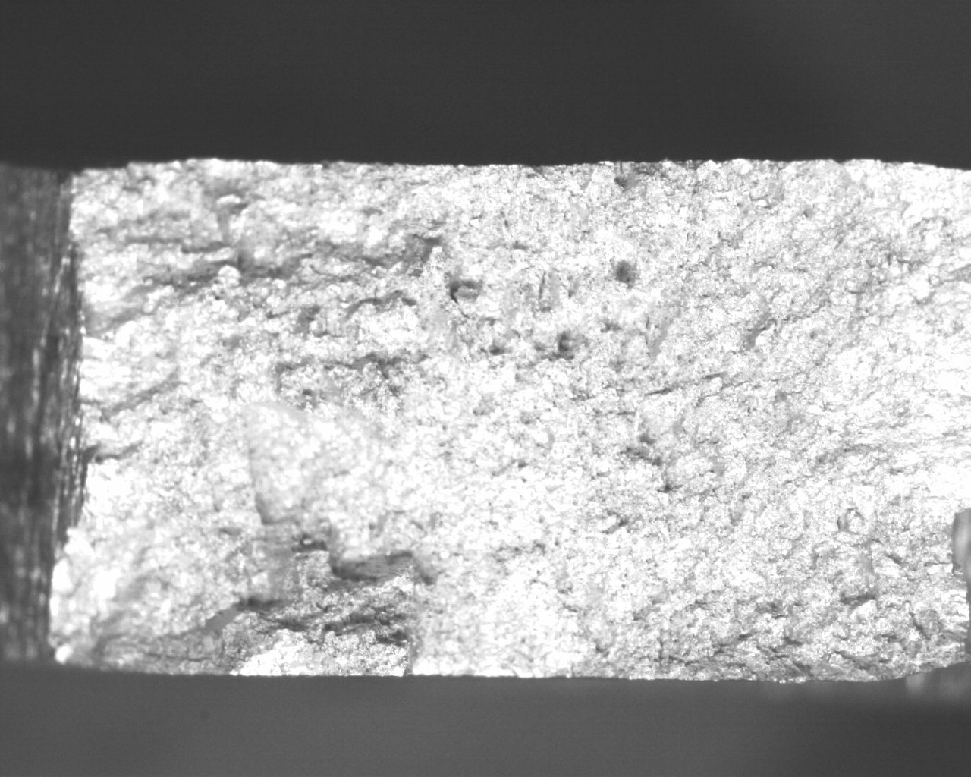
Figure 19a: Fracture surface from the base metal
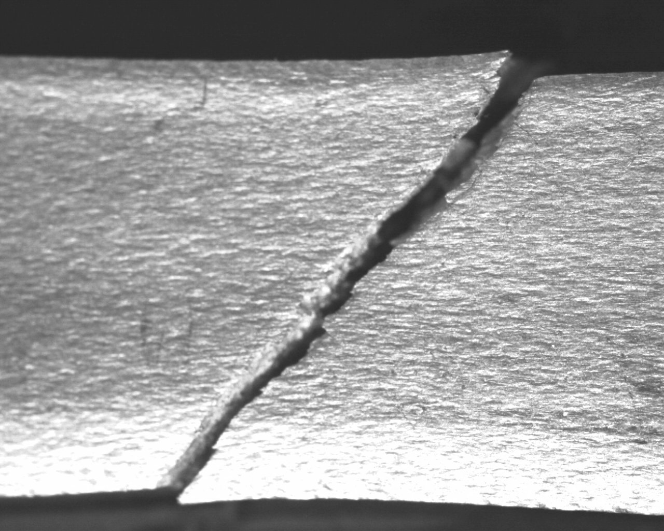
Figure19b: Crack that occurred during the tensile test
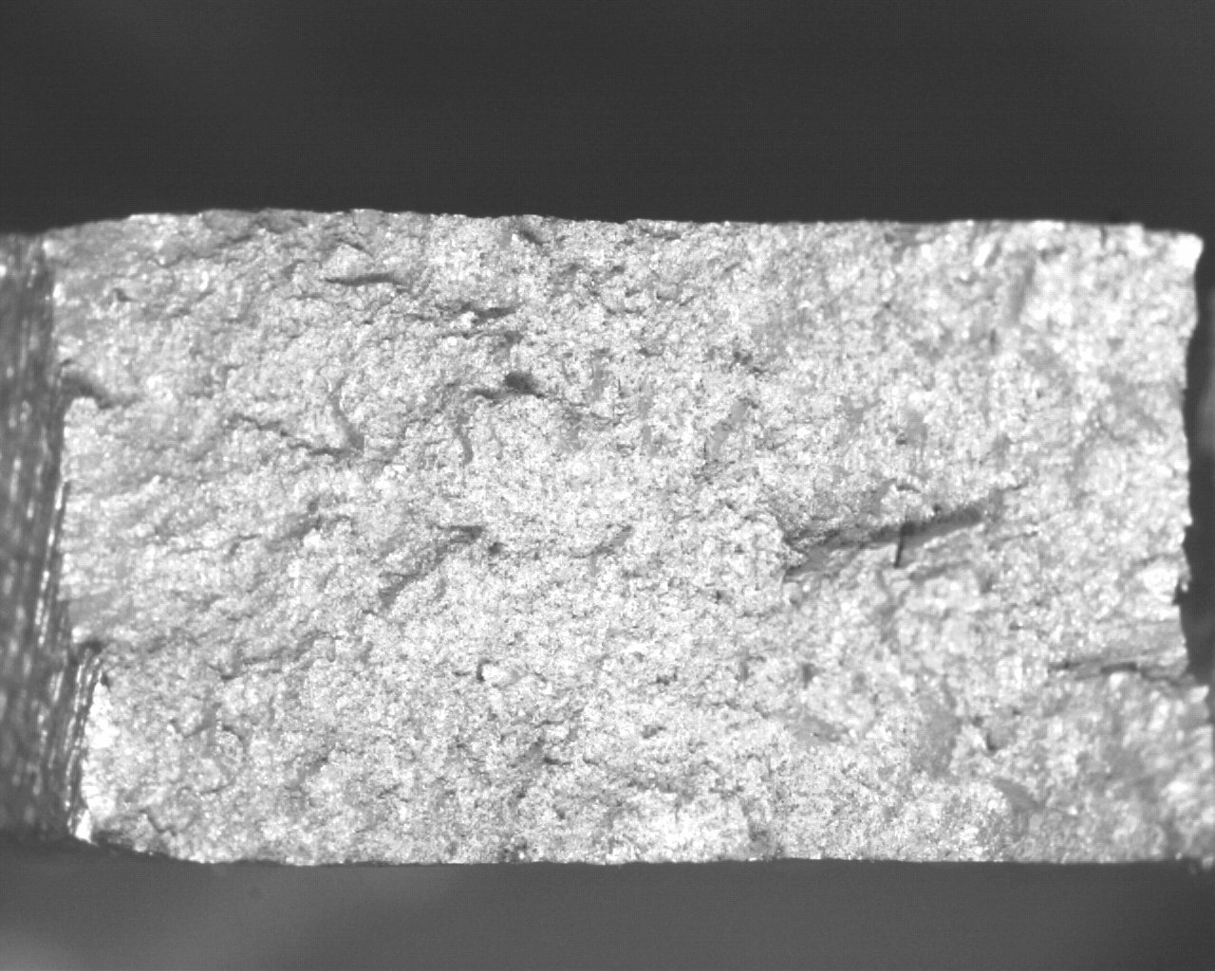
Figure 19c: Fracture surface from base metal

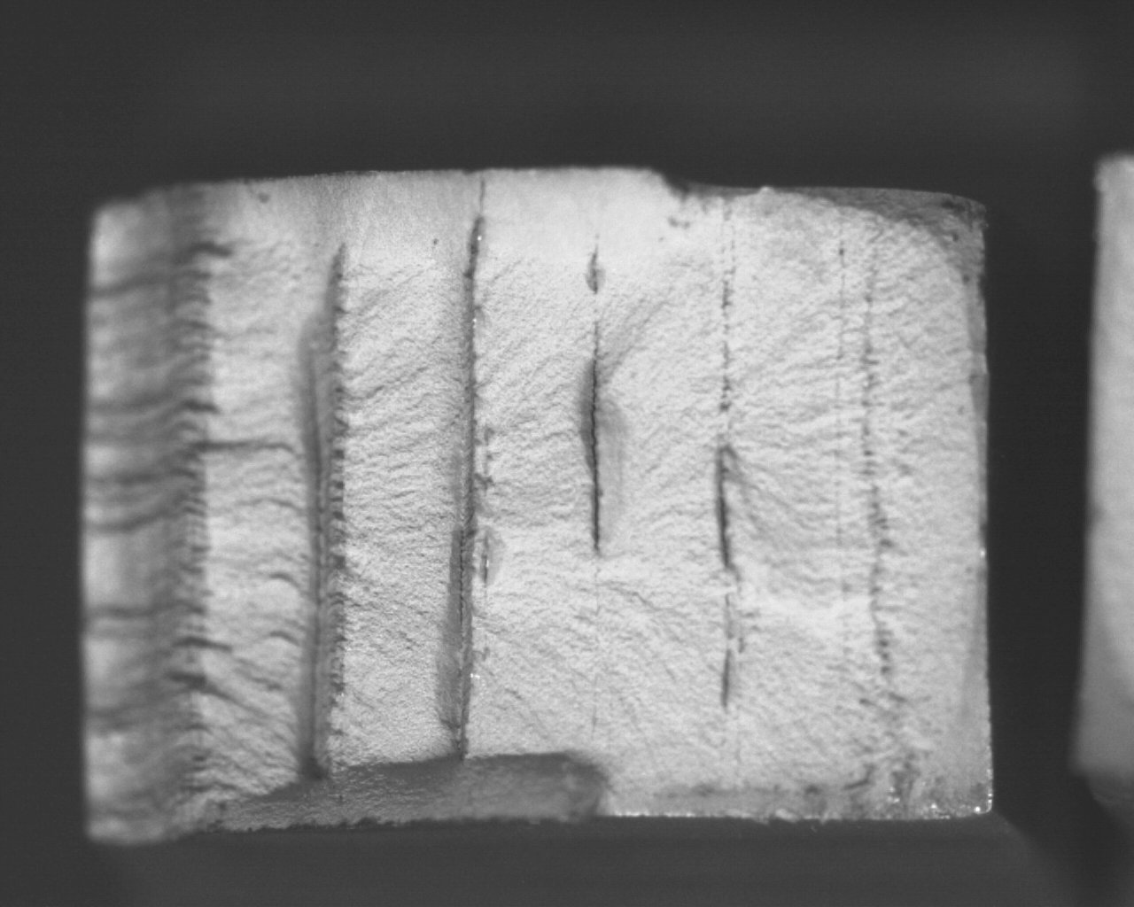
Figure 20a: Fracture surface from weld 009
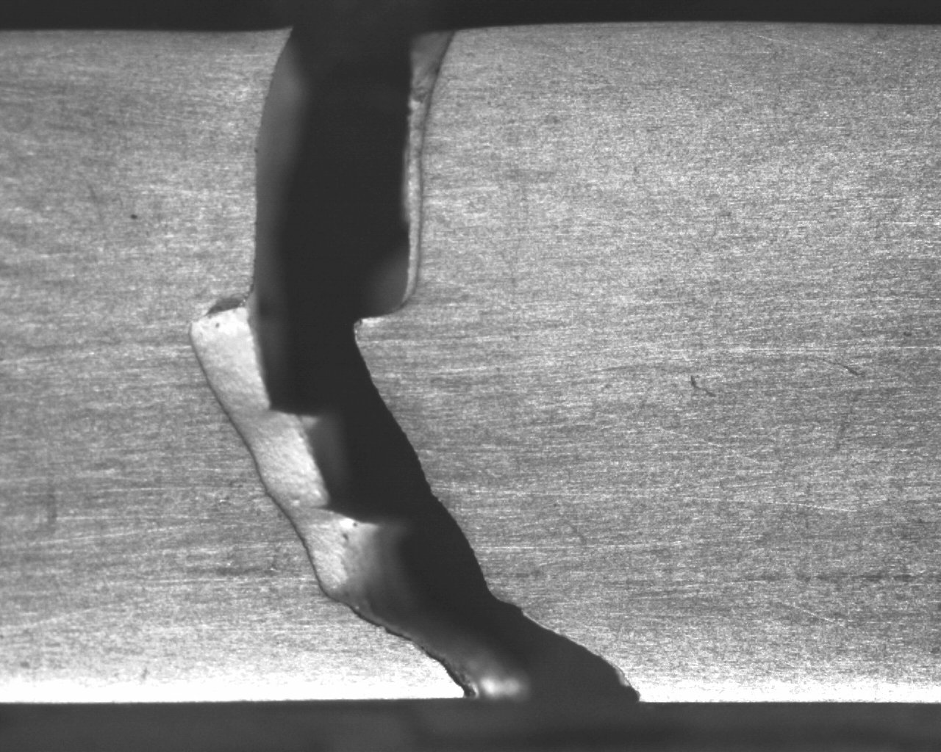
Figure 20b: Crack that occurred during the tensile test
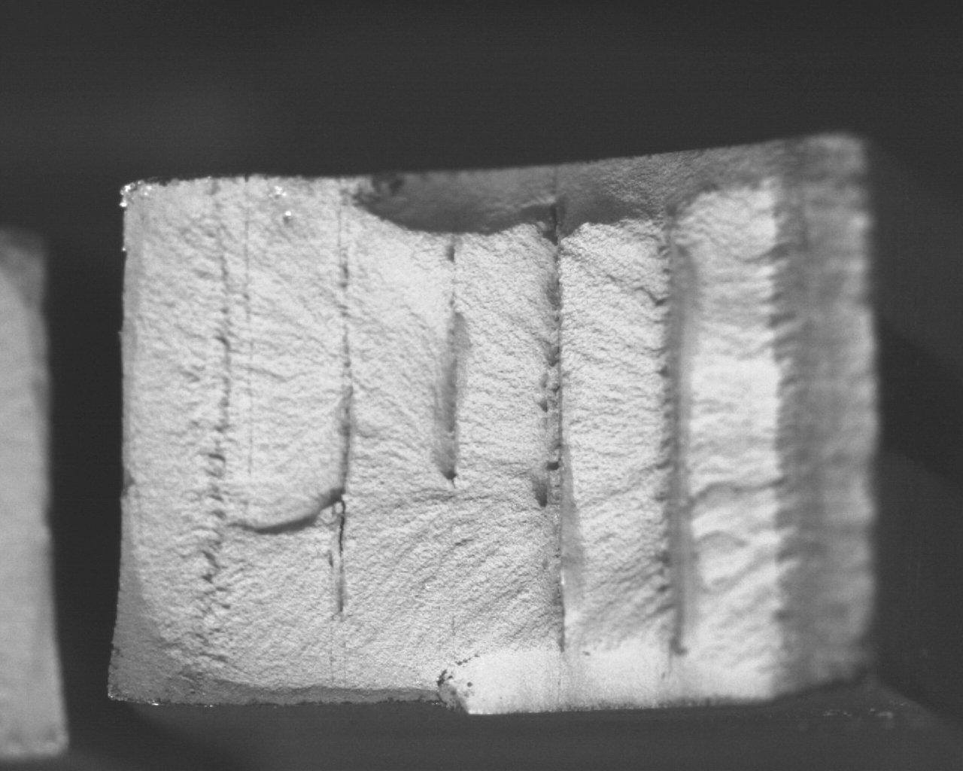
Figure 20c: Fracture surface from weld 009

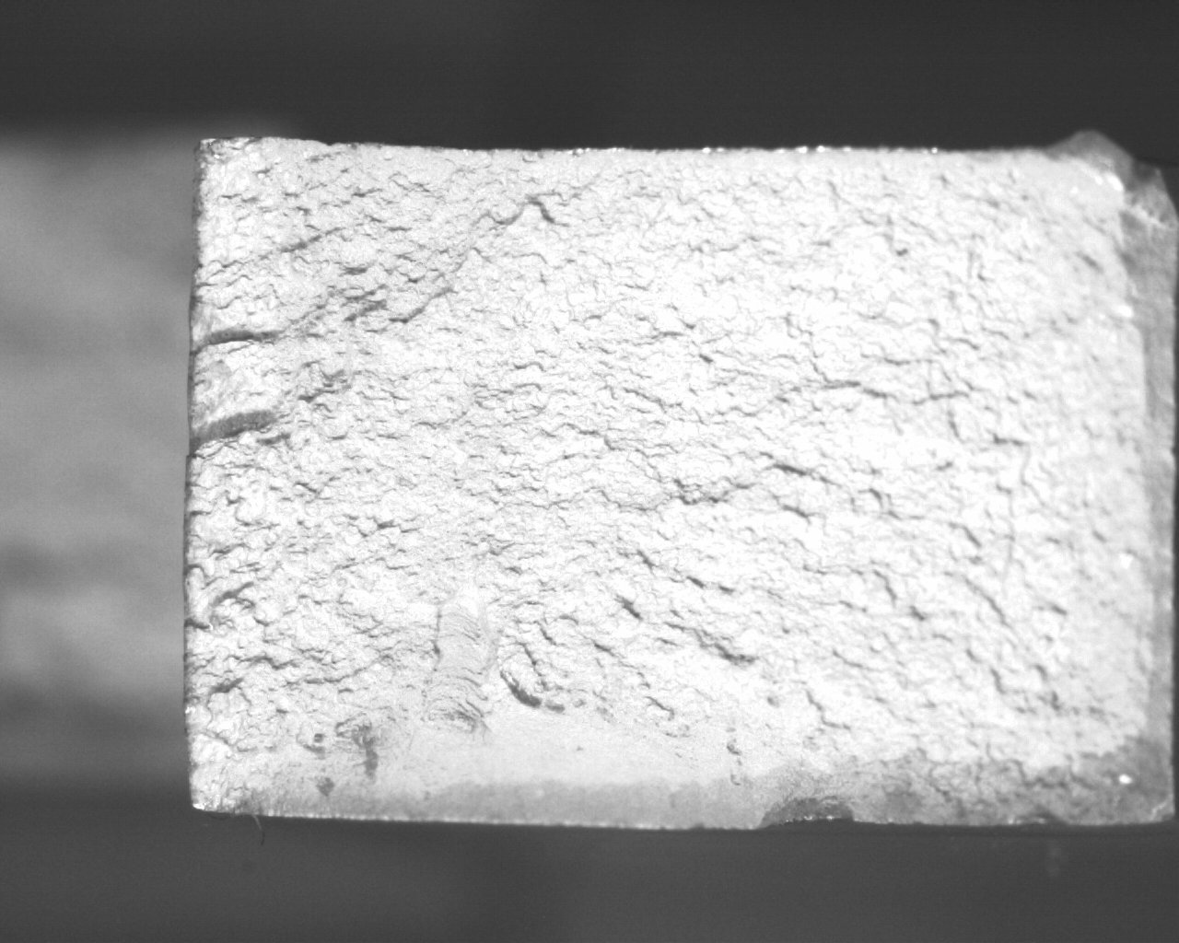
Figure 21a: Fracture surface from weld 010
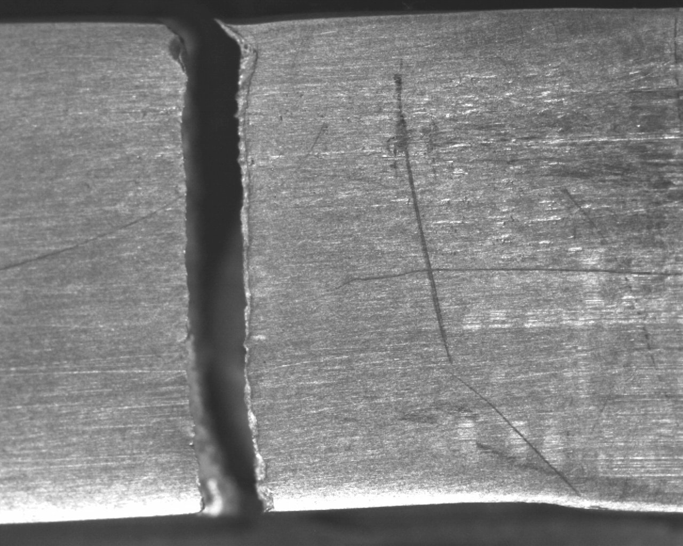
Figure 21b: Crack that occurred during tensile test
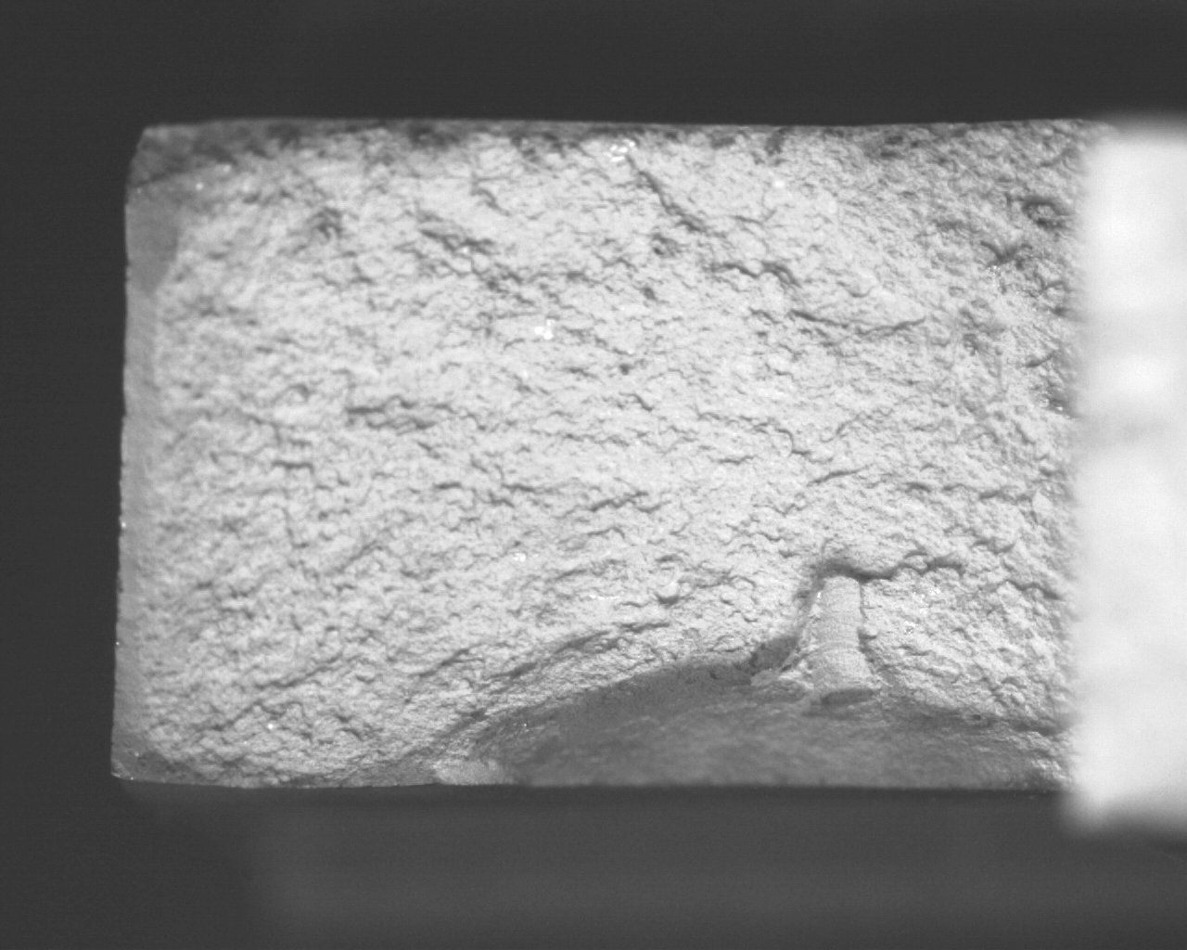
Figure 21c: Fracture surface from weld 010

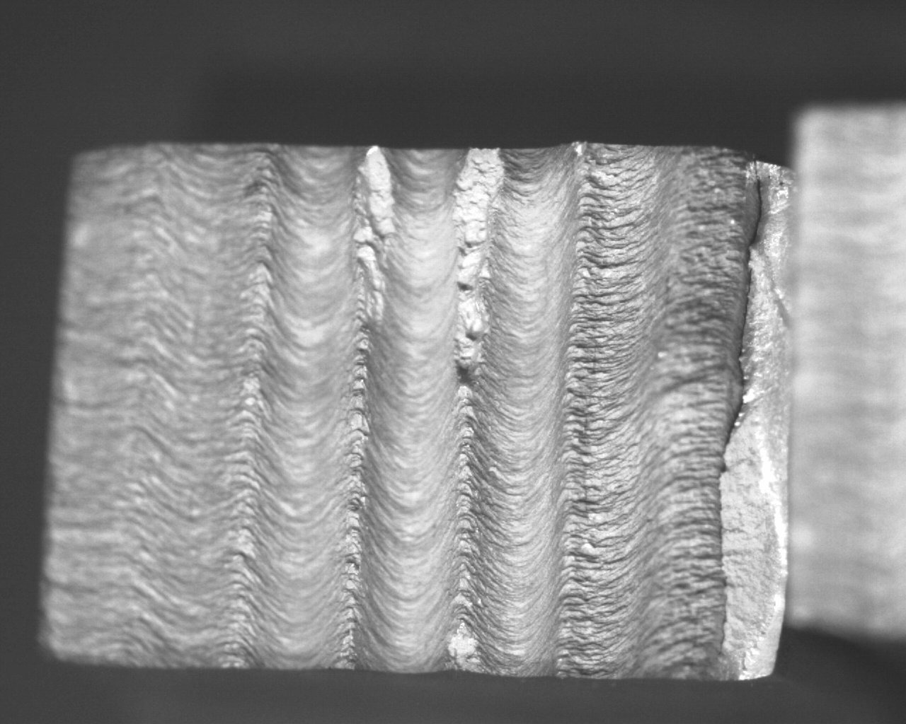
Figure 22a: Fracture surface from weld 011
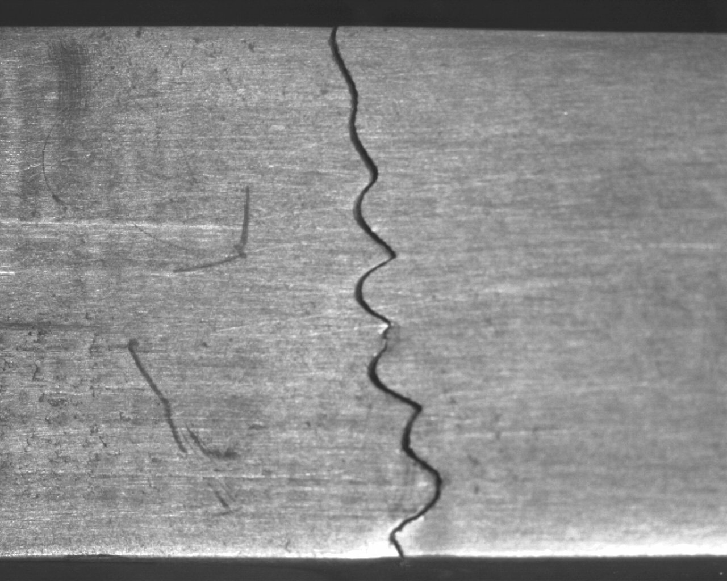
Figure 22b: Crack that occurred during tensile test
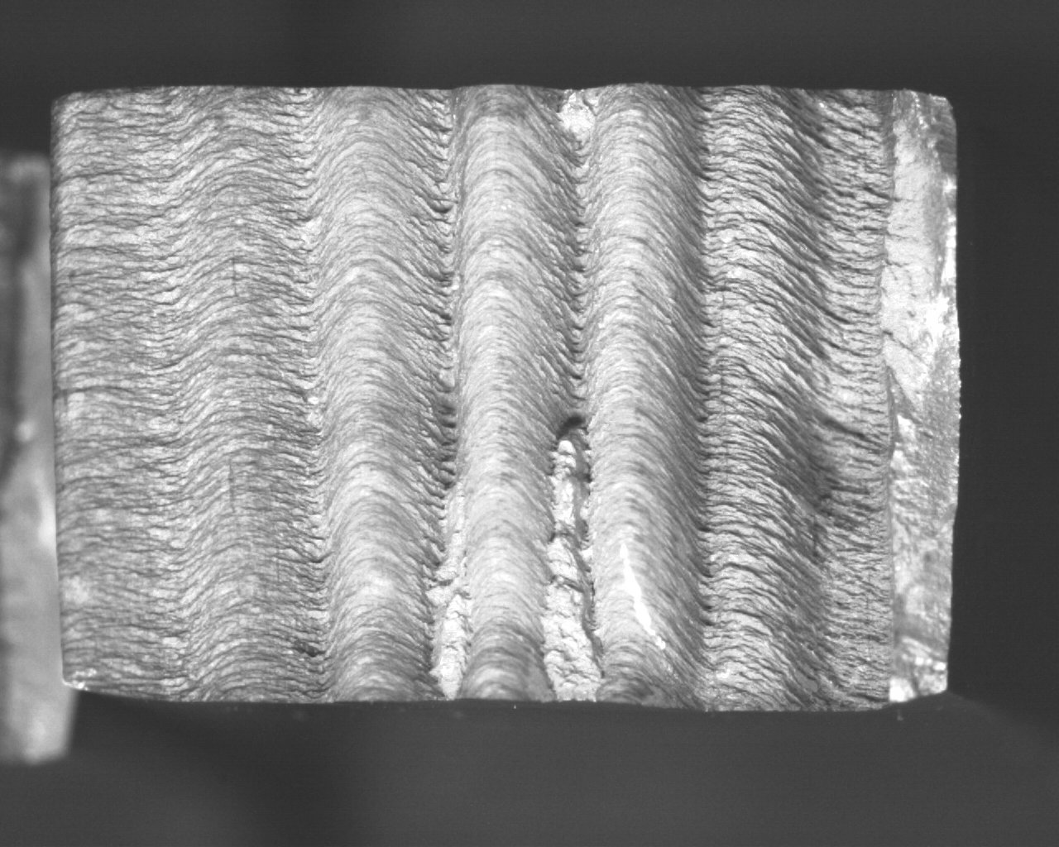
Figure 22c: Fracture surface from weld 011

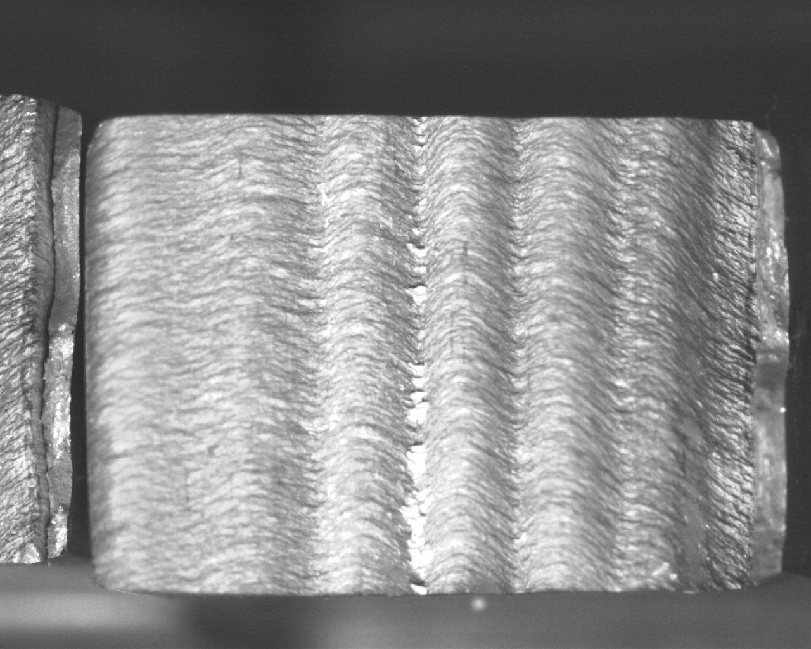
Figure 23a: Fracture surface from weld 012
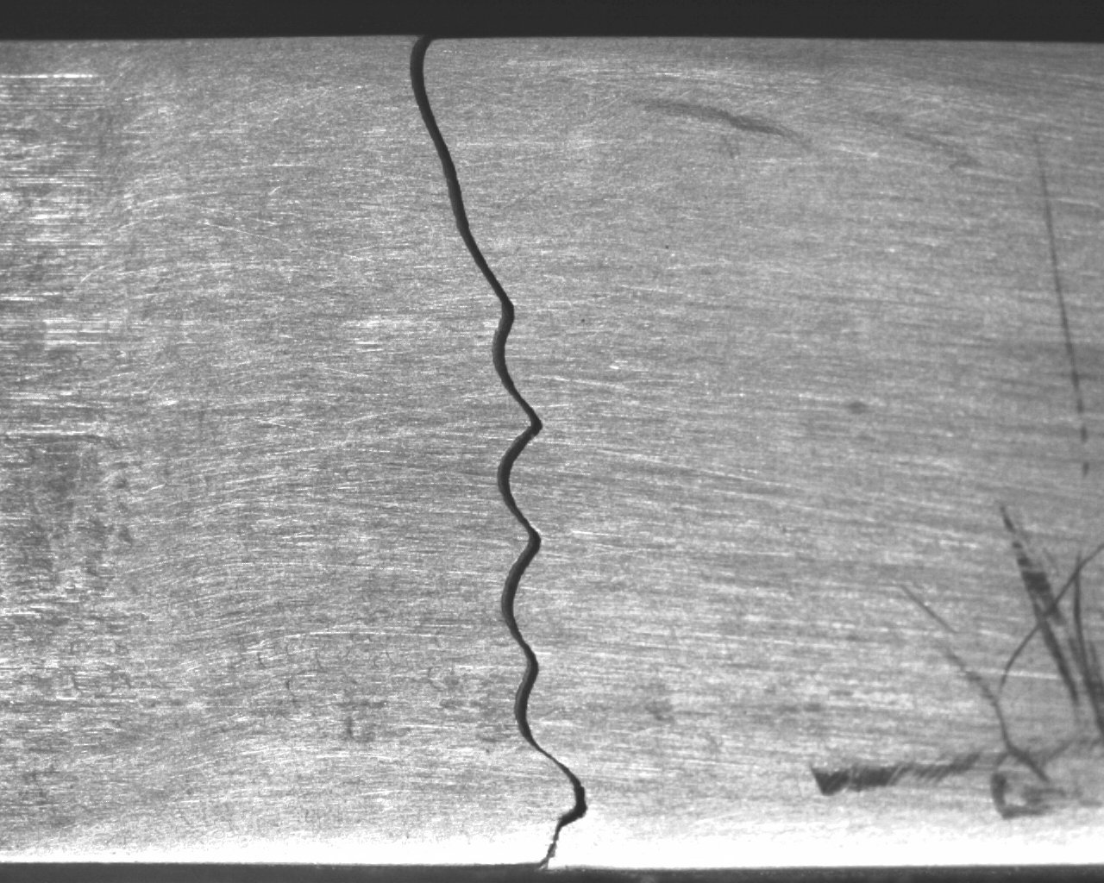
Figure 23b: Crack that occurred during tensile test
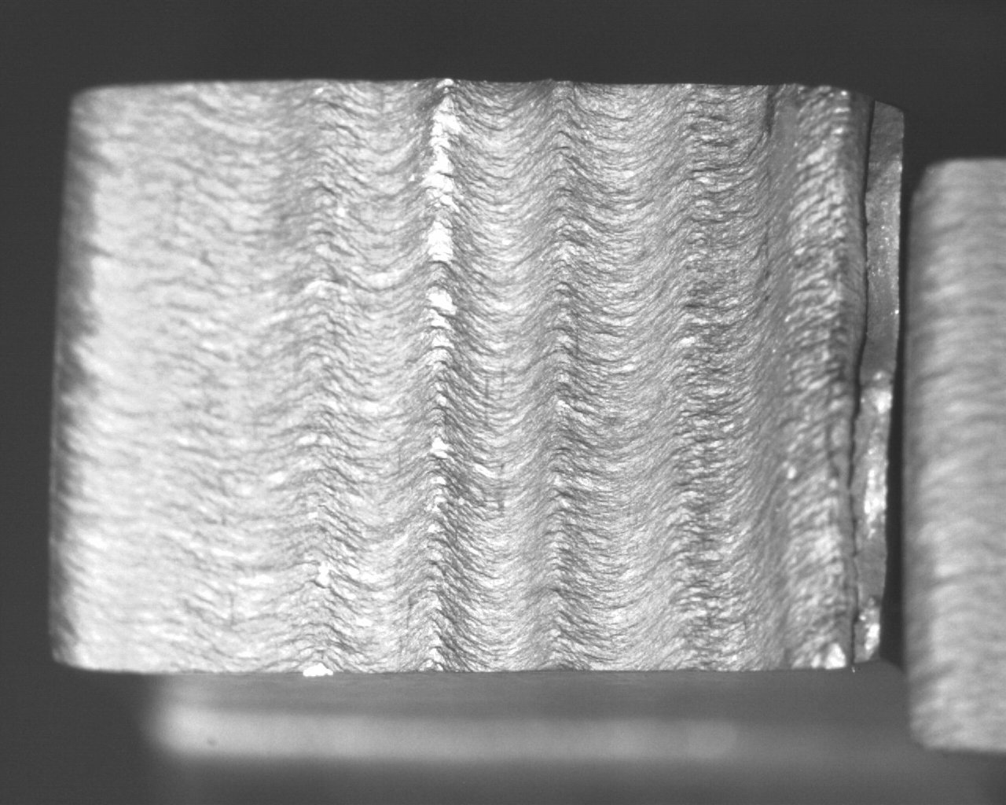
Figure 23c: Fracture surface from weld 012

Discussion
The analysis of the welds that revealed the presence of the “Lazy S” defect also showed that there were varying degrees of the defect in each weld. Weld 009 had a more signs of the “Lazy S” than weld 010, which is most likely due to the fact that one of the faying surfaces in weld 010 was milled down in order to remove the oxides that form the “Lazy S”. Weld 011 and 012 both had a fully formed “Lazy S” defects, but the varying offset influenced the definition of the defect. The defect in weld 012 was more defined than in weld 011. This is attributed to the fact that the increasing offset decreased the effect of the stirring action on the oxide layer. It seems that the more prominent the “Lazy S” defect, the more that the mechanical properties, specifically the tensile strength, are compromised.
Micro-hardness showed very minute changes in the mechanical properties of the welds, but that does not necessarily suggest that the micro-hardness was impacted by the presence of the defect. There is a variation in the hardness between welds, but this may be due to the fact that during experimentation, additional material was ordered. This change in material could account for the variation in micro-hardness. There is nothing to suggest that the “Lazy S” had any impact on the micro-hardness. This is most likely due to the small area that is affected by the defect. Since the “Lazy S” defect will only form a thin line along the weld nugget boundary, it is not surprising that the micro-hardness was not affected. The weld defect is so thin, that in a horizontal survey of the micro-hardness of a weld, only a single indentation would be affected, and that is only if the indentation is directly on the defect. It is not likely that an oxide array along a weld would have any impact on the micro-hardness of a weld.
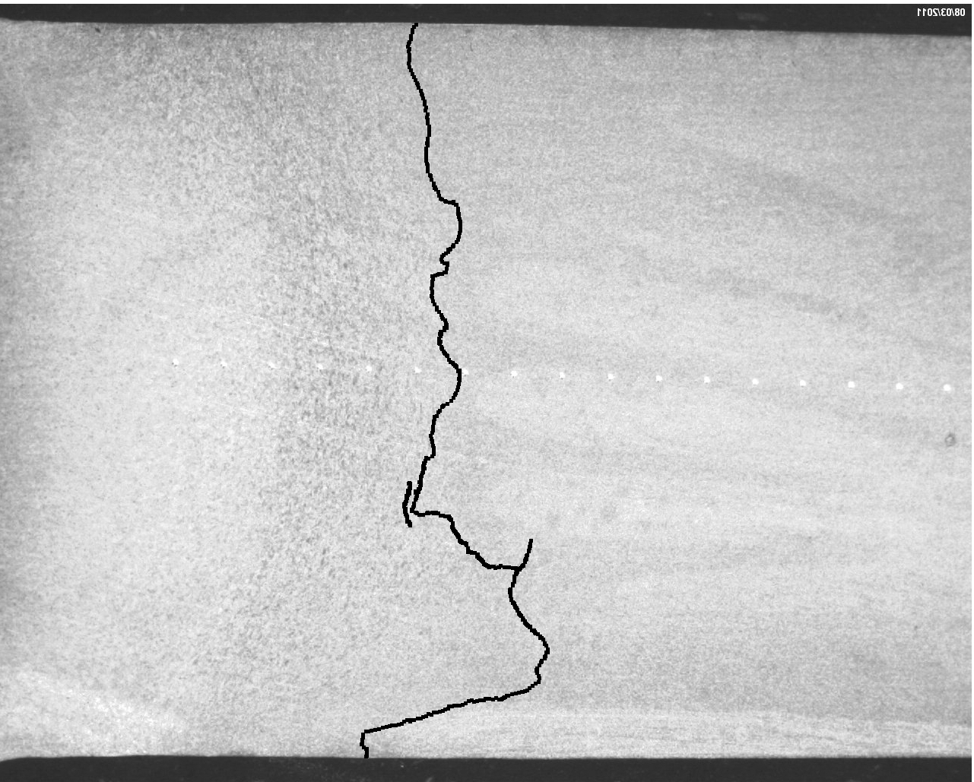
Tensile tests showed that the “Lazy S” defect had a heavy impact on the tensile properties of the weld. Based on the peak stress and the percentage of elongation (Table 6), the more defined the “Lazy S” defect is, the weaker the tensile properties of the weld becomes. Weld 012, which had the most definitive signs of the “Lazy S” defect, also had the weakest tensile properties and had virtually no elongation. Inversely, weld 010, which had the smallest signs of the defect, had a highest peak stress out of all the welds and had the closest elongation to that of the base metal. The profile of the fracture surface also indicates that the “Lazy S” seriously compromised the tensile properties of the welds. The fracture profile of welds 011 and 012 are a perfect outline of the “Lazy S” defect, which indicates that the defect was a weak point in the weld where the crack was initiated.
Figure 24 Top: Highlighted “Lazy S” defect in weld 011
Bottom: Fracture profile of tensile sample for weld 011

Conclusion
Based on the discoveries of the experimentation, the “Lazy S” defect has a significant impact on the mechanical properties of a self-reacting weld made with 2024-T4 Aluminum. The research found that while micro-hardness measurements showed minute differences in hardness, the tensile properties of the welds were substantially compromised by the presence of the “Lazy S” defect. The defect contributed to the initiation of cracks during tensile testing, and, in the case of welds 011 and 012, made up the entire fracture surface.

Future Work
There are many unknown factors that could be further explored regarding the “Lazy S” defect. Its formation in other types of alloys is a major area that could be investigated, as wells as investigating preventative measures to minimize the chance of its formation. Additionally, the relationship between the offset of the pin and the parameters could be explored in order to find the maximum offset distance that could be used for a particular set of parameters.

Acknowledgments
Thanks to the National Science Foundation grant # 0852057, and also to Drs. Michael West, Alfred Boysen, and Bharat Jasthi, and to the SDSM&T AMP Center.

References
[1] Sato, Y., Takauchi, H., et al., Characteristics of the kissing-bond in friction stir welded Al alloy 1050, Materials Science and Engineering A 405 (2005) 333–338.

[2] Warsinski, K., West, M., Freeman, J., & Curtis, T., Investigation of Lazy S Feature in Self- Reacting Tool Friction Stir Welds, (2010), TMS 2011 Conference, Retrieved from South Dakota School of Mines & Technology, June 2011.

[3] ASTM Standard E 8, 2009, Standard Test Methods for Tension Testing of Metallic Materials, ASTM International, West Conshohocken, PA, 203, DOI: 10.1520/E0008_E0008M-09, www.astm.org.

